**MINI PROJECT**

**SUNLIGHT TRACKER: SOLAR PANEL ANGLE ADJUSTMENT**

INDEX: -

|  |  |
| --- | --- |
| **S.NO** | **TOPIC PG.NO** |
| 1. | INTRODUCTION 5 |
| 2. | ABSTRACT 5 |
| 3. | OBJECTIVES 7 |
| 4. | MOTIVATION 7 |
| 5. | SURVEY 8 |
| 6. | a) BLOCK DIAGRAM 9-10  b) CIRCUIT DIAGRAM  c) FLOW CHART |
| 7. | PIN DIAGRAM 10 |
| 8. | HARD WARE AND SOFTWARE COMPONENTS 11 |
| 9. | METHODOLOGY 12 |
| 10. | PROGRAM CODE 13 |
| 11. | APPLICATIONS 15 |
| 12. | FUTURE CONTRIBUTIONS 17 |
| 13. | CONCLUSION 18 |

Sunlight Tracker: Solar Panel Angle Adjustment

# Abstract:

The design of this project involves creating a solar panel that can move in two axes - azimuth and elevation. Azimuth refers to the horizontal angle of the sun relative to the observer's position, while elevation refers to the vertical angle of the sun above the horizon. By adjusting both angles, we can ensure that the solar panel is always facing the sun directly.

To accomplish this, we will be using two servo motors - one for azimuth and one for elevation. These motors will be controlled by the Arduino UNO, which will be receiving input from various sensors that measure the angle of sunlight hitting the solar panel.

# Introduction:

* Sunlight Tracker is an Internet of Things (IoT) project that utilizes an Arduino UNO microcontroller to adjust the angle of a solar panel to face the sun for maximum energy efficiency.
* The project is aimed at providing an innovative and cost-effective solution for improving the performance of solar panels
* To address this need, sunlight tracker systems have been developed to automatically adjust the angle of solar panels based on the sun's position in the sky.
* These systems utilize various technologies such as sensors, actuators, and control algorithms to continuously monitor the sun's position and make precise adjustments to the solar panel's tilt or orientation.
* Sunlight tracker systems offer several advantages over fixed solar panel installations. By dynamically aligning the panels with the sun, they can increase energy generation by up to 30% compared to fixed installations.
* This improved performance allows for greater energy efficiency and a higher return on investment for solar power installations.
* In this paper, we will explore the concept of sunlight tracker systems for solar panel angle adjustment in detail.
* We will discuss the key components of these systems, including sun tracking algorithms, sensors, actuators, and control mechanisms. Furthermore, we will delve into different types of sunlight tracker systems, such as single-axis and dual-axis trackers, highlighting their advantages and limitations.

Top of Form

# Overview:

## Overview on Arduino

* Arduino is an open-source platform used for building electronics projects.
* Arduino consists of both a physical programmable circuit board (often referred to as a microcontroller) and a piece of software, or IDE (Integrated Development Environment) that runs on your computer, used to write, and upload computer code to the physical board.

## Light Dependent Resistor (LDR)

* A light-dependent resistor is made from semiconductor material having light-sensitive properties and hence are very sensitive to light.
* The resistance of LDR changes according to the light that falls on it and it is inversely proportional to the intensity of light.

## Solar panel

* A solar panel is a device which is an arrangement of multiple solar cells, which are connected in parallel or series alignment to observe sunlight and then generate direct current (DC).
* It is also known as Photovoltaic (PV) module

## Servo motor

* Servo motor is used to rotate the solar panel.
* We are using servo motor because we can control the position of our solar panels precisely and it can cover the whole path of sun.
* We are using a servo motor that can be operated with 5volt.

# Why did we choose this topic?

* It addresses a real-world problem.
* By building a sunlight tracker, someone can ensure that their solar panels are always optimally oriented, which can lead to increased energy production and cost savings
* Sunlight Tracker project combines practical applications with modern technology, making it a compelling and interesting project for those interested in renewable energy and electronics.

# Objectives:

* The primary objective of the Sunlight Tracker project is to increase the energy efficiency of solar panels by ensuring that they are always facing the sun.
* Develop an Arduino UNO based system that reads real-time sunlight intensity and position data using appropriate sensors.
* Use the data collected to determine the optimal angle for the solar panel to be positioned at.
* Develop a mechanism to adjust the angle of the solar panel based on the data collected.
* Implement a user interface that allows users to monitor the system's performance and make adjustments as needed.
* Enable the system to connect to the internet and upload data to a cloud-based platform for remote monitoring and analysis.
* By achieving these objectives, the Sunlight Tracker project will create an intelligent solar panel system that can maximize the output of solar power while minimizing energy waste. The project has significant implications for sustainable energy generation and has practical applications in both residential and commercial settings.

# Motivation:

* The motivation behind the Sunlight Tracker project is to provide an alternative solution for improving the performance of solar panels.
* Many existing solutions for solar panel tracking are expensive and complex, making them unsuitable for small-scale projects or home use.
* By developing an affordable and easy-to-use solution, the Sunlight Tracker project aims to make solar energy more accessible to individuals and organizations.
* Additionally, the project supports the global shift towards sustainable energy sources by maximizing the efficiency of solar panels.

Literature Survey:

The US Patent no. 0215199 A1 [2007] by Robert H. Dold describes a two- axis solar tracker capableofwithstanding the extreme weather conditions. The solar tracker includes a solar array, a frame, a base, a pivot frame, and a first and second actuator. The solar array is mounted to the frame and captures sunlight. The base is pivotally connected to the frame and defines a pivot axis for elevational movement of the solar array. The pivot frame is also pivotally connected to the frame and defines a pivot axis for azimuthal movement of the solar array. The base is pivotally connected to the frame and defines a pivot axis for elevational movement of the solar array. The pivot frame is also pivotally connected to the frame and defines a pivot axis for azimuthal movement of the solar array. The first actuator controls elevational movement of the solar array and the second actuator controls azimuthal movement of the solar array. The solar tracker is pivotable between a raised position and a stowed position.

The US patent No. 0308091 [2008] by Ronald P Corioclaimsas an object of the his invention to mechanically link multiple solar trackers in a large array configuration so that they may operate in unison, driven by a single motor and tracker controller, whereby the mechanical linkage system is designed such that it must only be capable of withstanding the relatively low forces required to effect movement of the trackers without the requirement to resist larger wind forces acting on the array of trackers. Another object of his invention is to apply the drive principles to various solar single-axis tracking geometries to maximize the economic performance for each solar tracking application. Multiple gearboxes can be mechanically linked by drive shafts and driven by a single motor. The drive shafts may incorporate universal joints for uneven terrain or staggered configurations. Harmonic dampers can be affixed to the solar panels to decouple wind forces which allow the use of larger solar panels.

Qiang Xiei’s US Patent No.0051017 A1 [2010] refers to a solar collector which may receive and direct solar radiation onto a photovoltaic (or, solar) cell. A concentrating solar collector may also convert the received solar radiation into a concentrated radiation beam prior to directing the radiation onto the solar cell. In some aspects, determination of the target tracker position in the second coordinate system includes subtracting 360° from an azimuth angle in the first coordinate system if the azimuth angle in the first coordinate system is between +180° and +360°, wherein the azimuth angle in the second coordinate system is determined to be equal to the azimuth angle in the first coordinate system if the azimuth angle in the first coordinate system is between 0 and +180°.

# Pin diagram:

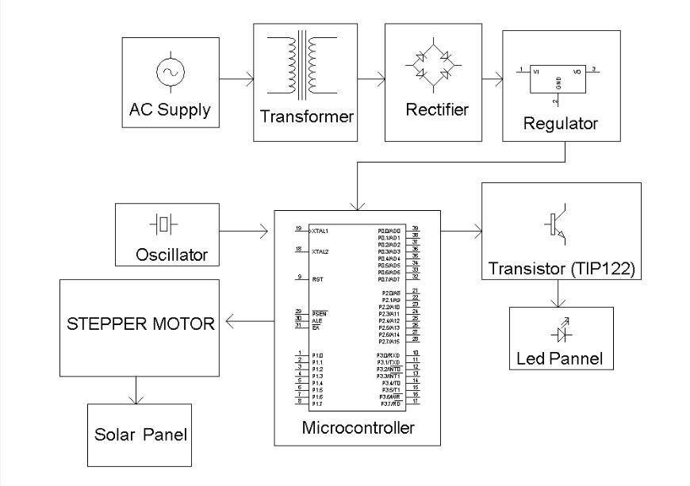

# Circuit Diagram for the project:

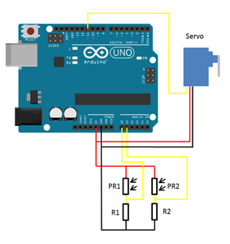

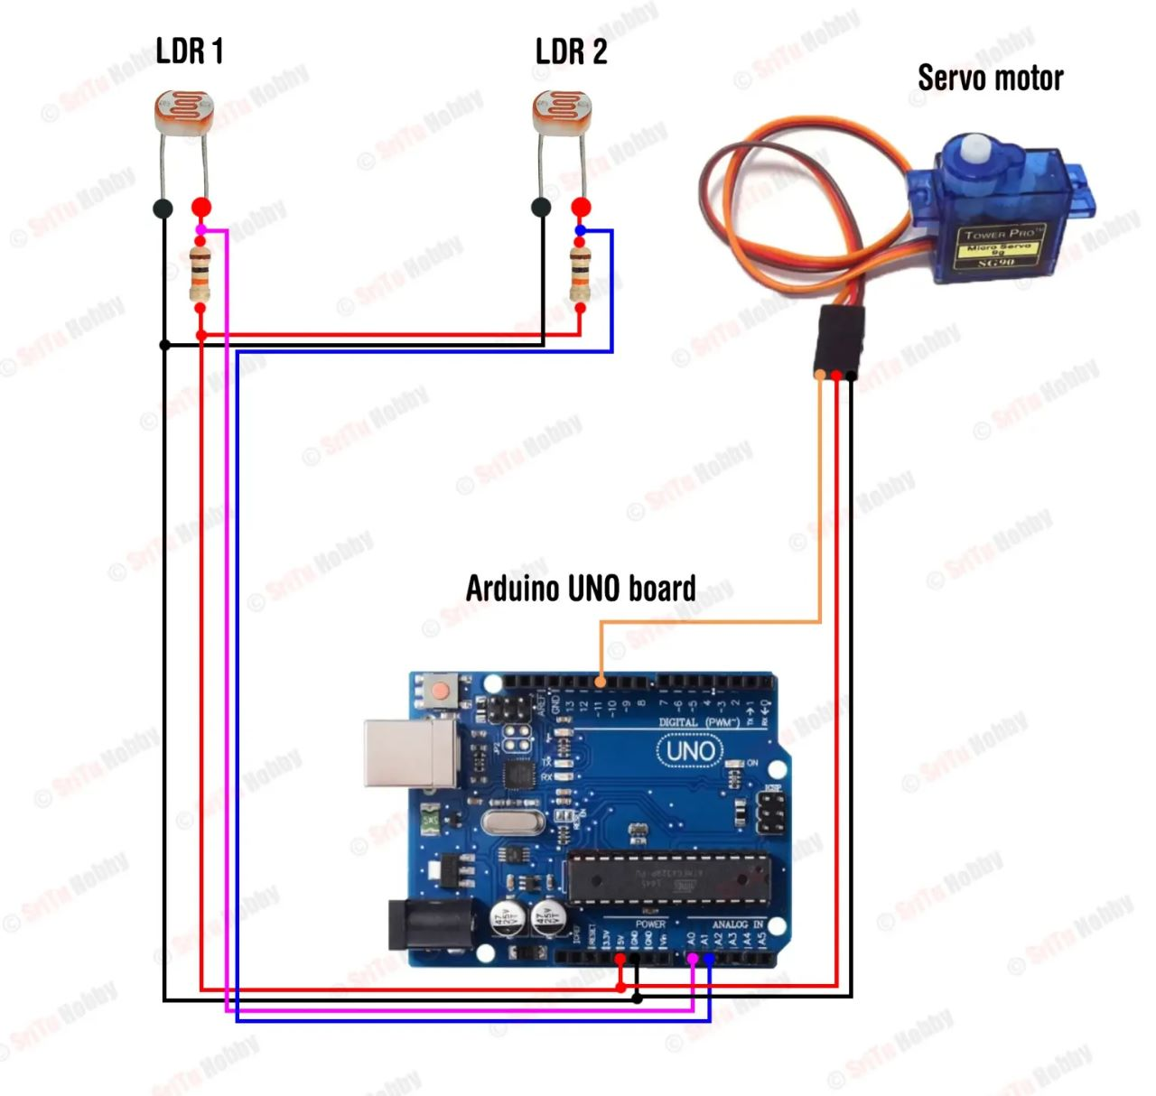

# Block Diagram:

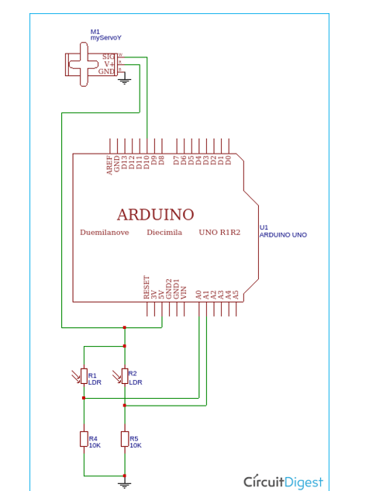

# Hardware and Software used:

## Hardware:

1. Arduino UNO board: It's a microcontroller board based on the ATmega328P. It's the heart of the project and will be responsible for controlling the system's various components.
2. Breadboard: It's a prototyping board that allows you to connect different components together without soldering.
3. LDR (Light Dependent Resistor): It's a resistor whose resistance changes according to the amount of light it's exposed to. It will be used to detect the sun's position in the sky.
4. Servo motor: It's a motor that rotates to a specific angle based on the signals received from the Arduino board. It will be used to adjust the angle of the solar panel.
5. Jumper wires: These are used to connect the various components together.
6. Solar panel: It's the component that converts sunlight into electrical energy.

|  |  |  |
| --- | --- | --- |
| **S.NO** | **HARDWARE USED** | **QUANTITY** |
| 1. | Arduino UNO board | 1 |
| 2. | Breadboard | 1 |
| 3. | LDR (Light Dependent Resistor) | 2 |
| 4. | Servo motor | 1 |
| 5. | Jumper wires | 10-15 |
| 6. | Solar panel | 1 |

## Software used:

1. Arduino IDE: It's an open-source software development environment that allows you to write and upload code to the Arduino board.
2. Servo library: It's a pre-built code library that simplifies the programming of the servo motor.

* Once you have all the components, you can start building the system. The LDR will detect the sun's position, and the Arduino board will use this information to rotate the servo motor and adjust the angle of the solar panel to maximize energy output.

# Methodology of project:

* The first step in building this project is to connect the Arduino UNO to the breadboard and wire up the servo motors. We will also need to connect the light sensor and potentiometer to the breadboard, as well as the power source for the motors.
* Once all of the components are wired up, we can begin programming the Arduino UNO to receive input from the sensors and control the motors accordingly. This will involve writing code in the Arduino IDE and uploading it to the microcontroller.
* Finally, we can mount the solar panel onto the rotating platform and attach the servo motors to it. We will also need to calibrate the sensors and adjust the code as necessary to ensure that the solar panel is tracking the sun accurately.
* With everything in place, the solar panel should now be able to adjust its angle according to the angle of sunlight hitting on it, maximizing its efficiency and output.

# Connection of the Solar Tracker:

* The connection of the circuit is very straightforward.
* Here, we used an Arduino Uno as controller and connected the 2 LDRs to analogue pin A0 and A1 respectively.
* Pin 9 of Arduino is connected to the servo motor.
* Since, we have used a 5V servomotor, we don’t require any external power supply because all the components can easily be powered the Arduino itself.
* All the connections are shown in the figure below.

# PROGRAM CODE:

include the servo motor library

#include <Servo.h>

#define LDR1 A0

#define LDR2 A1

#define error 10

int Spoint = 90;

Servo servo;

void setup() {

  servo.attach(11);

  servo.write(Spoint);

  delay(1000);

}

void loop() {

  int ldr1 = analogRead(LDR1);

  int ldr2 = analogRead(LDR2);

  int value1 = abs(ldr1 - ldr2);

  int value2 = abs(ldr2 - ldr1);

  if ((value1 <= error) || (value2 <= error)) {

  } else {

    if (ldr1 > ldr2) {

      Spoint = --Spoint;

    }

    if (ldr1 < ldr2) {

      Spoint = ++Spoint;

    }

  }

  servo.write(Spoint);

  delay(80);

}

# Result with outputs:

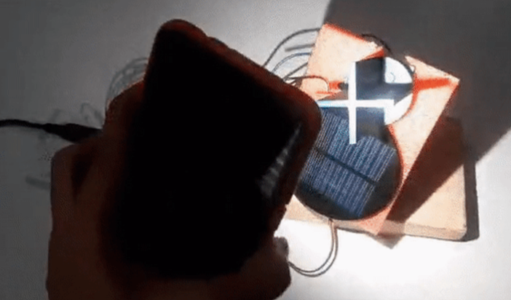

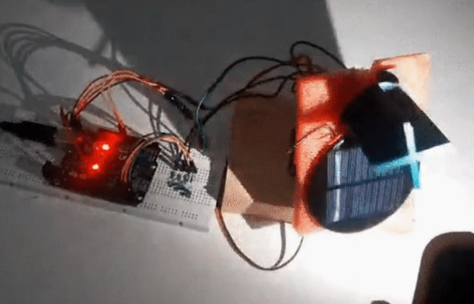

# **ADVANTAGES:**

* On the same amount of space, solar trackers generate more electricity than a fixed solar system which makes them ideal for optimizing land usage.
* There are two kinds of solar trackers, such as single-axis and dual-axis. A suitable solar tracker can be installed according to the Installation size, local weather, degree of latitude and electrical requirements
* Solar trackers generate more electricity than their stationary solar system due to direct exposure to solar rays.
* Also, the tracker system does not require long term maintenance because of the advancements in technology and reliability of mechatronics.
* In certain states, some utilities offer Time of Use (TOU) rate plans for solar power. This utility will purchase the power generated during the peak time of the day at a higher rate. The solar tracking system is used to maximize the energy gains during these peak time periods.

# Applications:

Solar trackers are devices used to orient photovoltaic panels, reflector, lenses other optical devices towards sun.

Since the suns position in the sky changes with seasons and the time of day, trackers are used to align the collection system to maximize energy production

Residential Solar Installations: Sunlight tracker systems can be installed in residential settings to optimize the energy generation of rooftop solar panels. By automatically adjusting the panel angles throughout the day, these systems ensure that the panels capture the maximum amount of sunlight, increasing energy production and reducing reliance on grid power.

Commercial and Industrial Solar Power Plants: Large-scale solar power plants, whether ground-mounted or rooftop installations, can greatly benefit from sunlight tracker systems. These systems enable precise alignment of solar panels, improving overall energy output and increasing the plant's efficiency. This is particularly valuable for utility-scale solar projects, where maximizing energy production is crucial for economic viability.

Off-Grid Systems: Sunlight tracker systems are also applicable to off-grid solar installations, such as remote cabins, campsites, or telecommunications towers. These systems ensure optimal solar panel positioning to maximize energy generation and support self-sufficiency in areas without access to the power grid.

Agricultural and Irrigation Systems: Solar panels are increasingly used to power agricultural operations, such as irrigation pumps, crop drying systems, or greenhouse facilities. By implementing sunlight tracker systems, farmers can enhance the efficiency of their solar power systems and optimize energy production for agricultural processes, leading to cost savings and sustainable practices.

Mobile and Portable Solar Solutions: Sunlight tracker systems can be integrated into portable solar panels, solar chargers, or solar-powered devices. These applications are valuable for outdoor enthusiasts, hikers, or emergency situations, as they provide a reliable and efficient power source that adjusts to the sun's position on the go.

Research and Experimental Projects: Sunlight tracker systems are utilized in research projects and experimental setups where precise control over solar panel angles is required. These systems help researchers study the effects of varying angles on energy generation, analyze the performance of different solar panel technologies, and optimize solar energy utilization in specialized applications.

Educational Demonstrations: Sunlight tracker systems are often used as educational tools to showcase the principles of solar energy and tracking technology. They enable students and enthusiasts to observe firsthand how solar panels can be aligned with the sun for improved performance, fostering understanding and awareness of renewable energy concepts.

In summary, sunlight tracker systems for solar panel angle adjustment have diverse applications across residential, commercial, industrial, portable, and research settings. By optimizing solar panel positioning, these systems enhance energy generation, improve efficiency, and contribute to the widespread adoption of solar power as a sustainable energy solution.

Top of Form

# Inference of Mini Project:

Increased Energy Generation: By continuously tracking the sun's position and adjusting the angle of solar panels, sunlight tracker systems maximize the absorption of sunlight. This leads to higher energy generation compared to fixed installations, potentially increasing energy output by up to 30%.

Improved Efficiency: By aligning solar panels with the sun's trajectory, sunlight tracker systems ensure that panels operate at their optimal angle of incidence. This maximizes the conversion of sunlight into electricity, improving the overall efficiency of solar power systems.

Cost Savings: With increased energy generation and improved efficiency, sunlight tracker systems can contribute to significant cost savings. By producing more electricity, solar power installations can reduce reliance on grid power and lower energy bills, providing a return on investment over time.

Adaptability to Changing Sunlight Conditions: The sun's position in the sky changes throughout the day and varies based on geographical location and time of year. Sunlight tracker systems dynamically adjust the panel angles to follow the sun's movement, ensuring optimal energy capture regardless of changing sunlight conditions.

Application Flexibility: Sunlight tracker systems can be applied to various scenarios, including residential installations, commercial and industrial solar power plants, off-grid systems, agricultural applications, portable solar solutions, research projects, and educational demonstrations. This highlights their versatility and wide-ranging applicability.

Sustainable Energy Solution: By optimizing solar energy generation, sunlight tracker systems contribute to the utilization of renewable energy sources. Solar power is clean, renewable, and reduces greenhouse gas emissions, making sunlight tracker systems an environmentally friendly choice for energy production.

# Conclusion and future works:

In conclusion, this project demonstrates the power of IoT technology to create smarter and more efficient devices. By utilizing an Arduino UNO microcontroller and various sensors and motors, we were able to create a solar panel that can track the sun and adjust its angle in real time.

This project has numerous practical applications, from improving the efficiency of solar panels in residential and commercial settings to optimizing the performance of solar-powered vehicles and drones. With the continued growth of IoT technology, we can expect to see even more innovative projects like this in the future.

# Reference:

1. Shintemirov et al., "A sensorless MPPT-based solar tracking control approach for mobile autonomous systems," IECON 2016 - 42nd Annual Conference of the IEEE Industrial Electronics Society, Florence, Italy, 2016, pp. 3006-3011, doi: 10.1109/IECON.2016.7793551.
2. S. K. Manjhi, R. Rohan and D. Kumar, "Comparison of Static and Single Axis Solar Tracker," 2022 IEEE 2nd International Symposium on Sustainable Energy, Signal Processing and Cyber Security (iSSSC), Gunupur, Odisha, India, 2022, pp. 1-5, doi: 10.1109/iSSSC56467.2022.10051252.
3. A. B. Afarulrazi, W. M. Utomo, K. L. Liew and M. Zarafi, "Solar Tracker Robot using microcontroller," 2011 International Conference on Business, Engineering and Industrial Applications, Kuala Lumpur, Malaysia, 2011, pp. 47-50, doi: 10.1109/ICBEIA.2011.5994256.
4. R. Santhosh, A. Ramachandran, A. S and R. Mahalakshmi, "Hardware design of Single axis solar tracker and MPPT charge controller using PIC18F4520," 2022 International Conference on Electronics and Renewable Systems (ICEARS), Tuticorin, India, 2022, pp. 51-56, doi: 10.1109/ICEARS53579.2022.9752007.
5. A. Sawant, D. Bondre, A. Joshi, P. Tambavekar and A. Deshmukh, "Design and Analysis of Automated Dual Axis Solar Tracker Based on Light Sensors," 2018 2nd International Conference on I-SMAC (IoT in Social, Mobile, Analytics and Cloud) (I-SMAC)I-SMAC (IoT in Social, Mobile, Analytics and Cloud) (I-SMAC), 2018 2nd International Conference on, Palladam, India, 2018, pp. 454-459, doi: 10.1109/I-SMAC.2018.8653779.